# **Quick start user guide**

The below screen is the login page of the application. The user needs to enter the admin credentials.

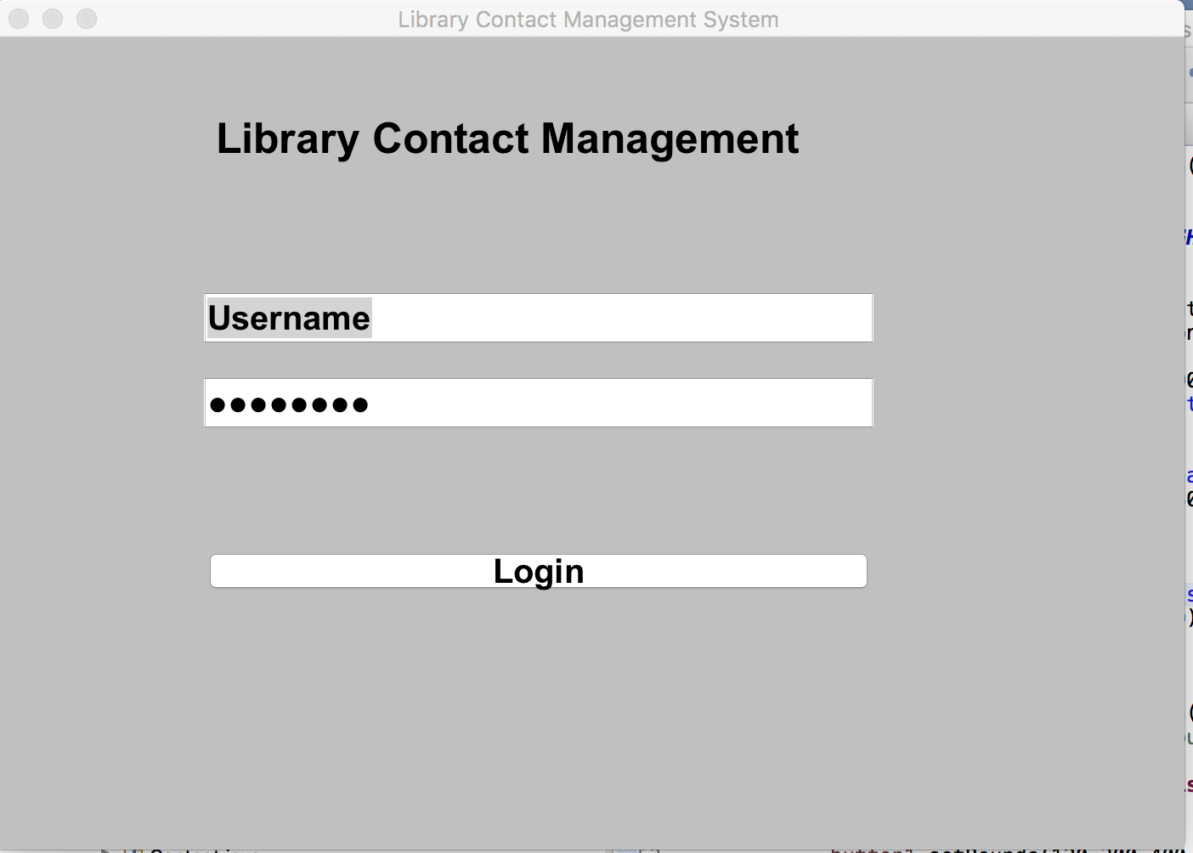

The next page lists the option that allows the user to add or search contacts.

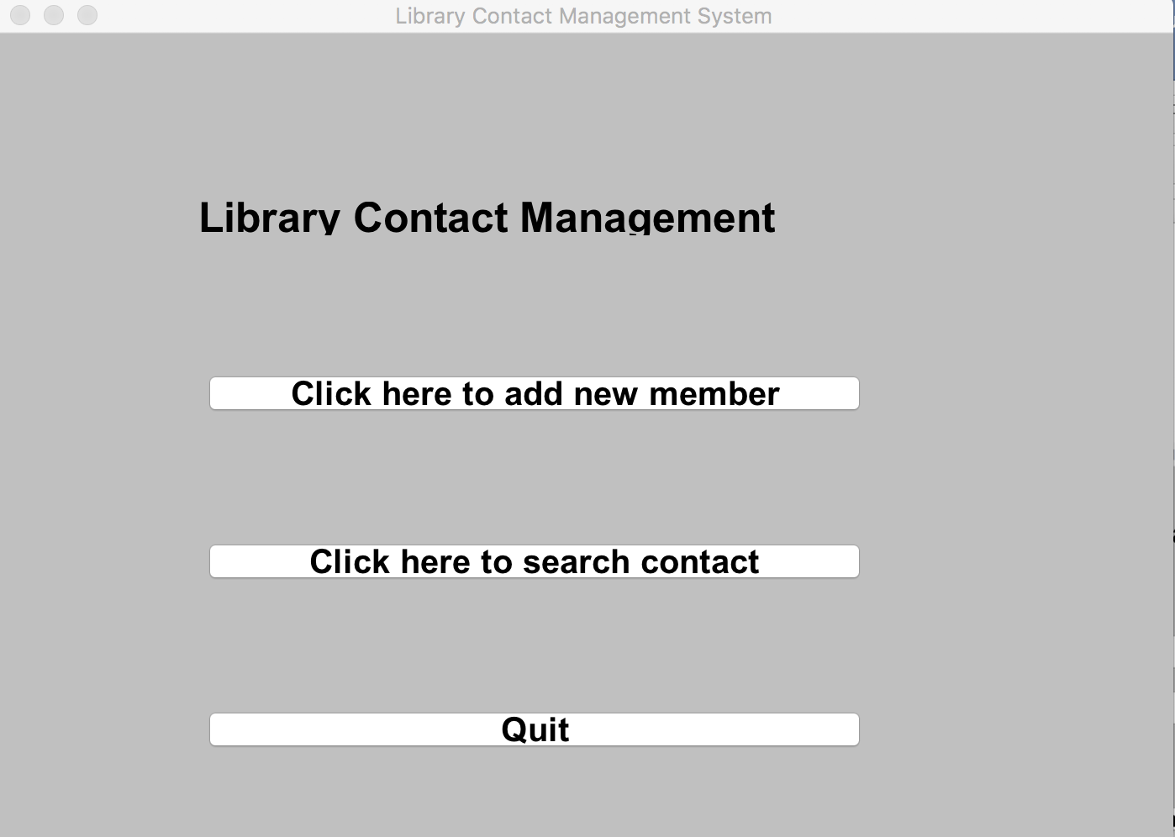

The below form is to be filled to add a contact to the database.

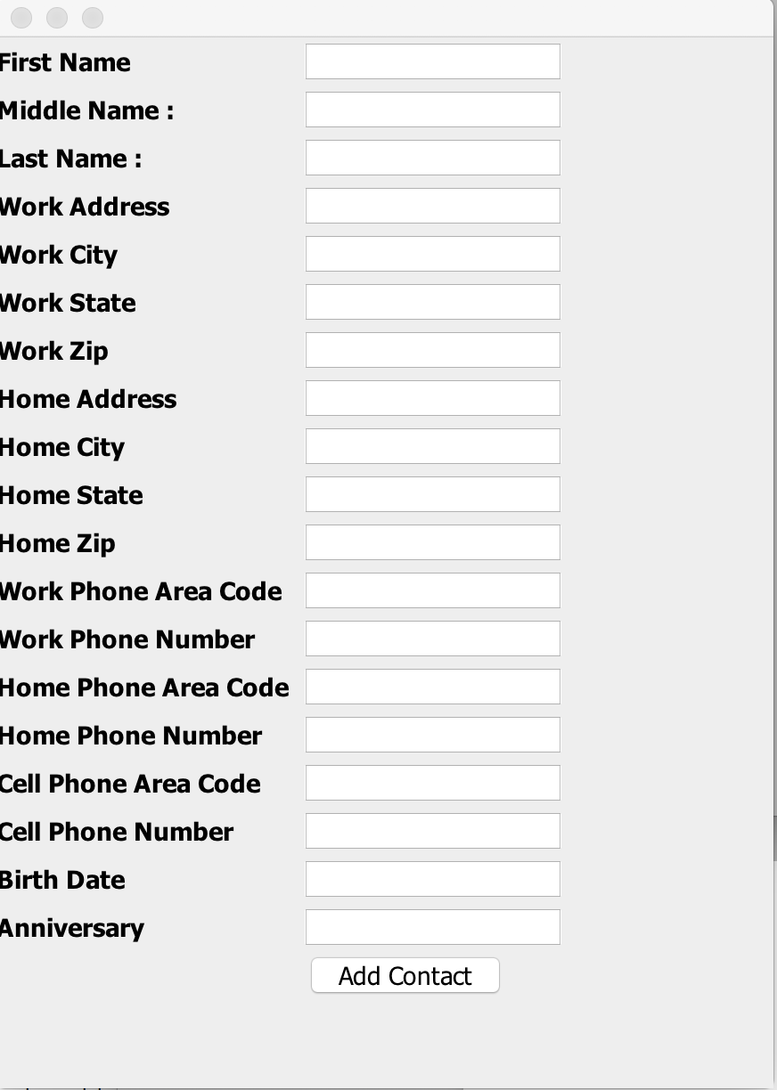

The search form as below will be displayed if the user select Search menu wherein the user needs to enter the keyword that needs to be searched.

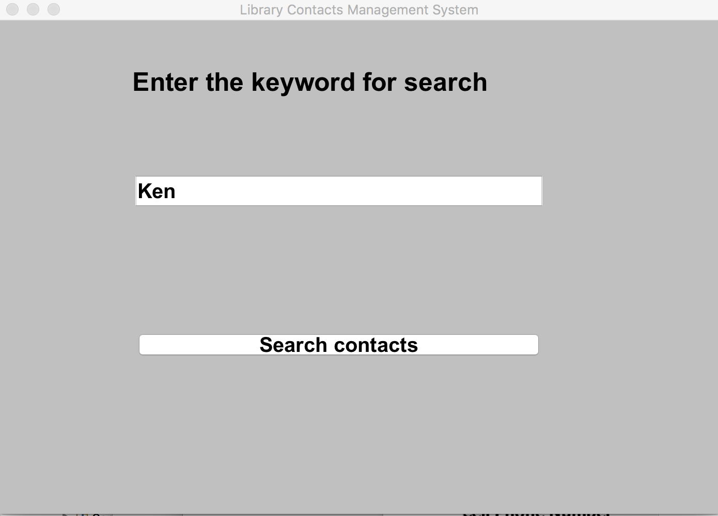

Upon hitting the Search button, the below results will be displayed in the tabular form.

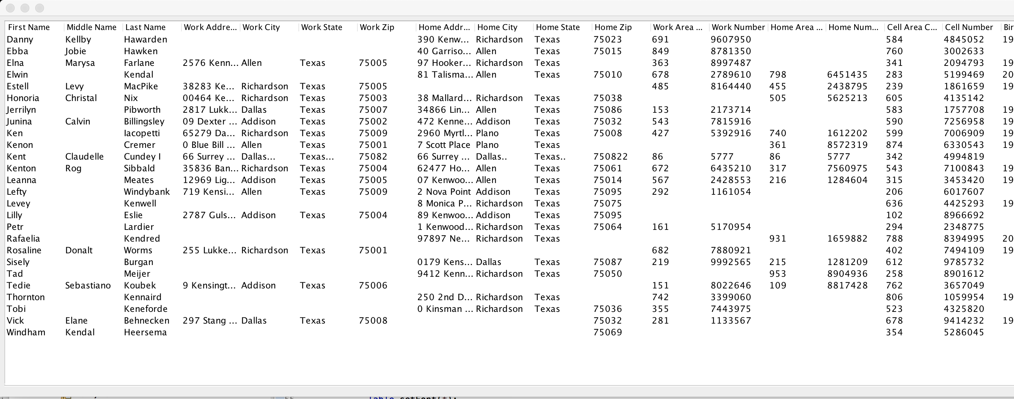

The user has to click on the record to update or delete which opens the below form.

